**Aim:**To develop software design document for Stock Market Website.

1. **Introduction:-**
   1. **Purpose: -** The purpose of this document is to describe the detailed description design of Stock Market Website which is developed by students of Chandigarh University.
   2. **Scope: -**The document describes the detail about Stock Market Website. The project consists of mainly 4 section NSE,BSE,Commodities,Global Indices.
   3. **Reference:-**

* <https://wikipedia.com>
* <https://stackoverflow.com>
* <https://tutorialspoint.com>
* <https://youtube.com>
* <https://github.com>

1. **Design consideration:-**
   1. **Assumptions: -**

* Market Values might not be fully Accurate.
* Predictions might be wrong.
  1. **Constraints:-**
* Predictions are subject to market risks
* The Tutor should be registered so that he/she can upload materials of courses provided by the website.
* The End User should be login/registered to ask doubts about the topics and subtopics.
  1. **System Environment:-**
* The web based Online tutorials Website can be accessible in any Operating System (MAC, Windows, Linux and any other).
* Only requirement is the Internet Connection.
* It can be accessible any time (24*7).
  1. **Design methodology:-**
* The system is designed with flexibility for further development and/or modification.
* The system is divided into manageable processes that are grouped to sub-modules and modules that are built with abstraction.

1. **Architecture:-**
   1. System Design(Diagram):-

**DATA FLOW DIAGRAM LEVEL 0**

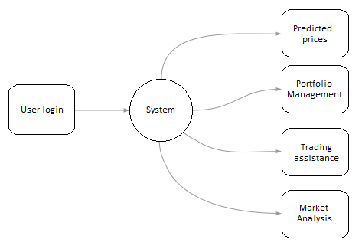

**DATA FLOW DIAGRAM LEVEL 1**

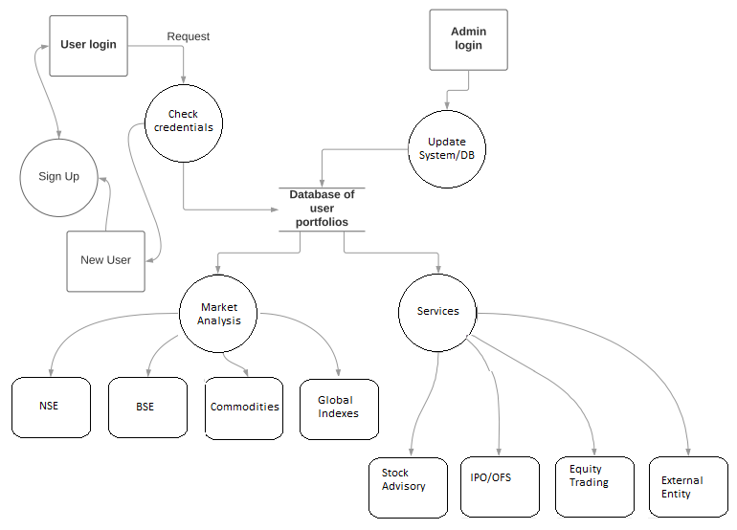

**ENTITY-RELATIONSHIP (ER) DIAGRAM**

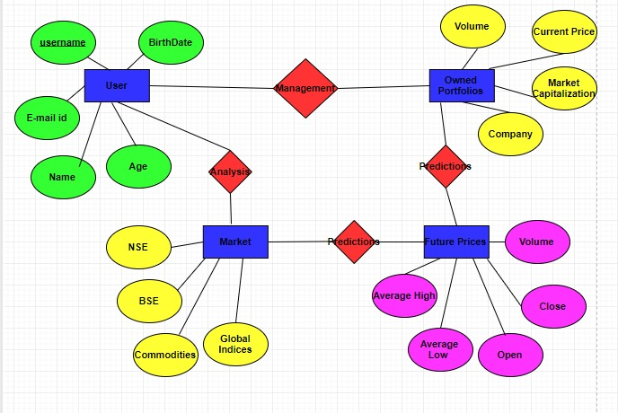

**AIM: -**Perform web application Testing using Selenium tool for Web Application Testing .

**THEORY:**

### What is Web Testing?

Web Testing in simple terms is checking your web application for potential bugs before its made live or before code is moved into the production environment.

During this stage issues such as that of web application security, the functioning of the site, its access to handicapped as well as regular users and its ability to handle traffic is checked.

## Web Application Testing Checklist:

Some or all of the following testing types may be performed depending on your web testing requirements.

## 1. Functionality Testing:

This is used to check if your product is as per the specifications you intended for it as well as the functional requirements you charted out for it in your developmental documentation. Testing Activities Included:

**Test**all **links**in your webpages are working correctly and make sure there are no broken links. Links to be checked will include -

* Outgoing links
* Internal links
* Anchor Links
* Mail to Links

**Test Forms**are working as expected. This will include-

* Scripting checks on the form are working as expected. For example- if a user does not fill a mandatory field in a form an error message is shown.
* Check default values are being populated

**Test Cookies** are working as expected. Cookies are small files used by websites to primarily remember active user sessions so you do not need to log in every time you visit a website. Cookie Testing will include

* Delete cookies (sessions) and test that login credentials are asked for when you next visit the site.

## ****2. Usability testing****:

[Usability Testing](https://www.guru99.com/usability-testing-tutorial.html) has now become a vital part of any web based project. It can be **carried out by testers** like you **or a small focus group** similar to the target audience of the web application.

**Test**the **Content**:

* Content should be legible with no spelling or grammatical errors.
* Images if present should contain an "alt" text

## ****3. Interface Testing****:

Three areas to be tested here are - Application, Web and Database Server

* **Application:** Test requests are sent correctly to the Database and output at the client side is displayed correctly. Errors if any must be caught by the application and must be only shown to the administrator and not the end user.
* **Web Server**: Test Web server is handling all application requests without any service denial.
* **Database Server:**Make sure queries sent to the database give expected results.

**Test system response** when **connection between the three layers**(Application, Web and Database) **cannot be established** and appropriate message is shown to the end user.

## 4. Database Testing:

Database is one critical component of your web application and stress must be laid to test it thoroughly. Testing activities will include-

* Test if any errors are shown while executing queries
* Data Integrity is maintained while creating, updating or deleting data in database.

## 5. Compatibility testing.

Compatibility tests ensures that your web application displays correctly across different devices. This would include-

**Browser Compatibility Test**: Same website in different browsers will display differently. You need to test if your web application is being displayed correctly across browsers, JavaScript, AJAX and authentication is working fine. You may also check for[Mobile](https://www.guru99.com/mobile-testing.html)Browser Compatibility.

## 6. Performance Testing:

This will ensure your site works under all loads. Testing activities will include but not limited to -

* Website application response times at different connection speeds
* Load test your web application to determine its behavior under normal and peak loads
* Stress test your web site to determine its break point when pushed to beyond normal loads at peak time.
* Test if a crash occurs due to peak load, how does the site recover from such an event

## 7. Security testing:

[Security Testing](https://www.guru99.com/what-is-security-testing.html) is vital for e-commerce website that store sensitive customer information like credit cards. Testing Activities will include-

* Test unauthorized access to secure pages should not be permitted
* Restricted files should not be downloadable without appropriate access
* Check sessions are automatically killed after prolonged user inactivity
* On use of SSL certificates, website should re-direct to encrypted SSL pages.

This concludes almost all testing types applicable to your web application.

As a Web-tester it’s important to note that web testing is quite an arduous process and you are bound to come across many obstacles. Make sure you **plan your work** and know clearly what is expected of you. Its best **define all the tasks** involved in your web testing and then **create a work chart for accurate estimates and planning**.